|  |
| --- |
| *Customer*  *Favorites & Upcoming Events*  Our classic **Chocolate Eclairs** and **Cream Puffs** are back by popular demand. There's never a wrong time for a sweet, creamy indulgence.  Halloween Treats: Get ready for a spooky sweet season! We're planning a special Halloweenthemed treat day for kids and kids-at-heart. |

AZHARA SWEETS AND BAKES

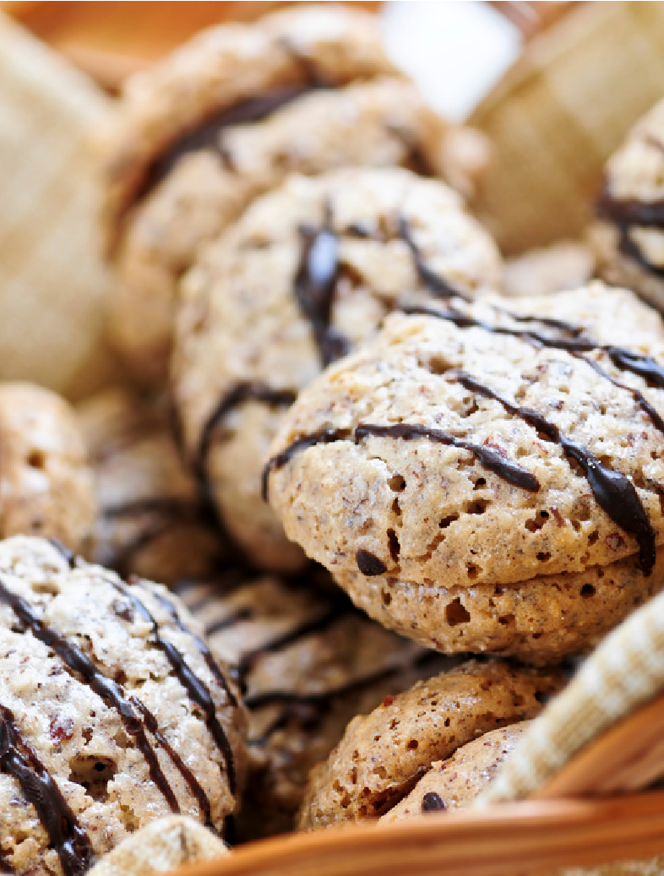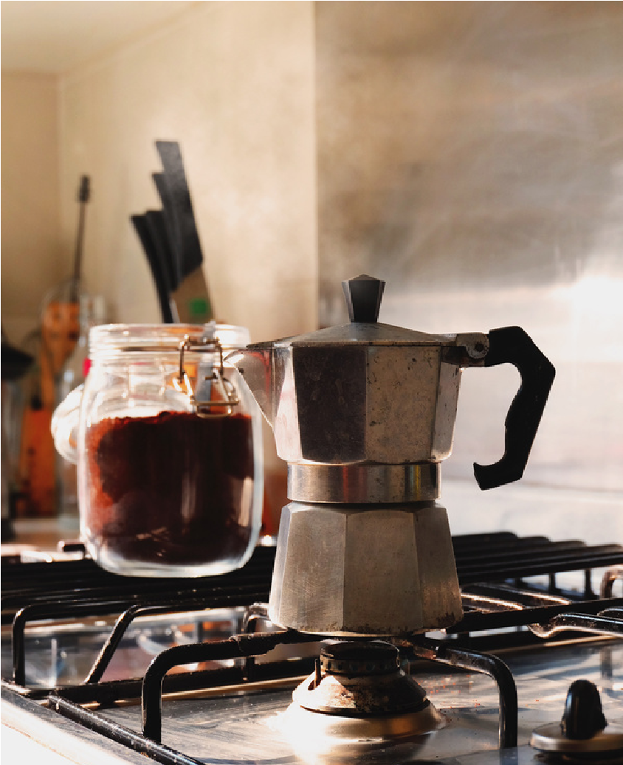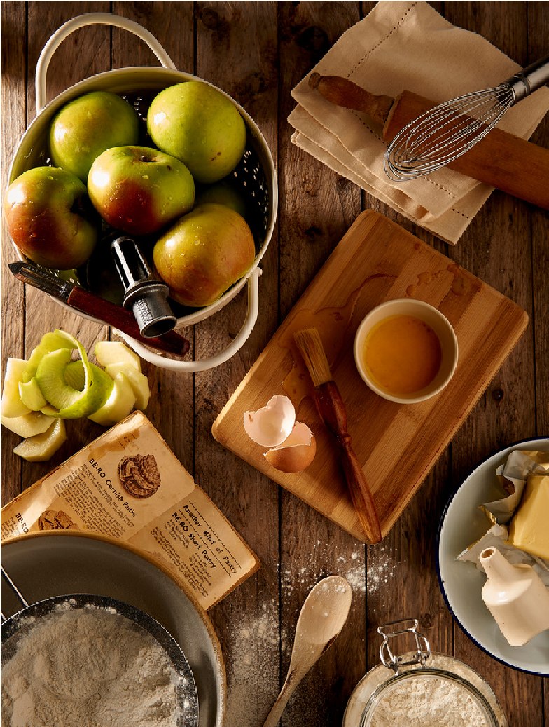

*What's Roasting?*

**B Y K A N I**

Welcome to the Sweet Delights Newsletter - your source for all things sweet and savory from our bakery! As the crisp autumn leaves fall, we're embracing the cozy vibes with a delightful assortment of pastries, cakes, and treats that will warm your heart. This month, we've got a menu filled with scrumptious options and exciting updates, so let's dive right in!

*We love hearing from our customers! If you have any suggestions, comments, or just want to share your Sweet Delights experience, please reach out to us at azharasweets@gmail.com. Thank you for choosing Sweet Delights as your go-to bakery. We look forward to serving you and making your day a little sweeter! Wishing you a cozy and delicious autumn season. Sweet regards,*

**B Y R A H U L , N I J A N T H A N**

Stay Connected:

Don't forget to follow us on our social media platforms for the latest updates, behind-the-scenes sneak peeks, and fun baking tips.

Facebook:https://www.facebook.com/azh arasweets instagram:https://instagram.com/azharas weets?igshid=OGQ5ZDc2ODk2ZA==

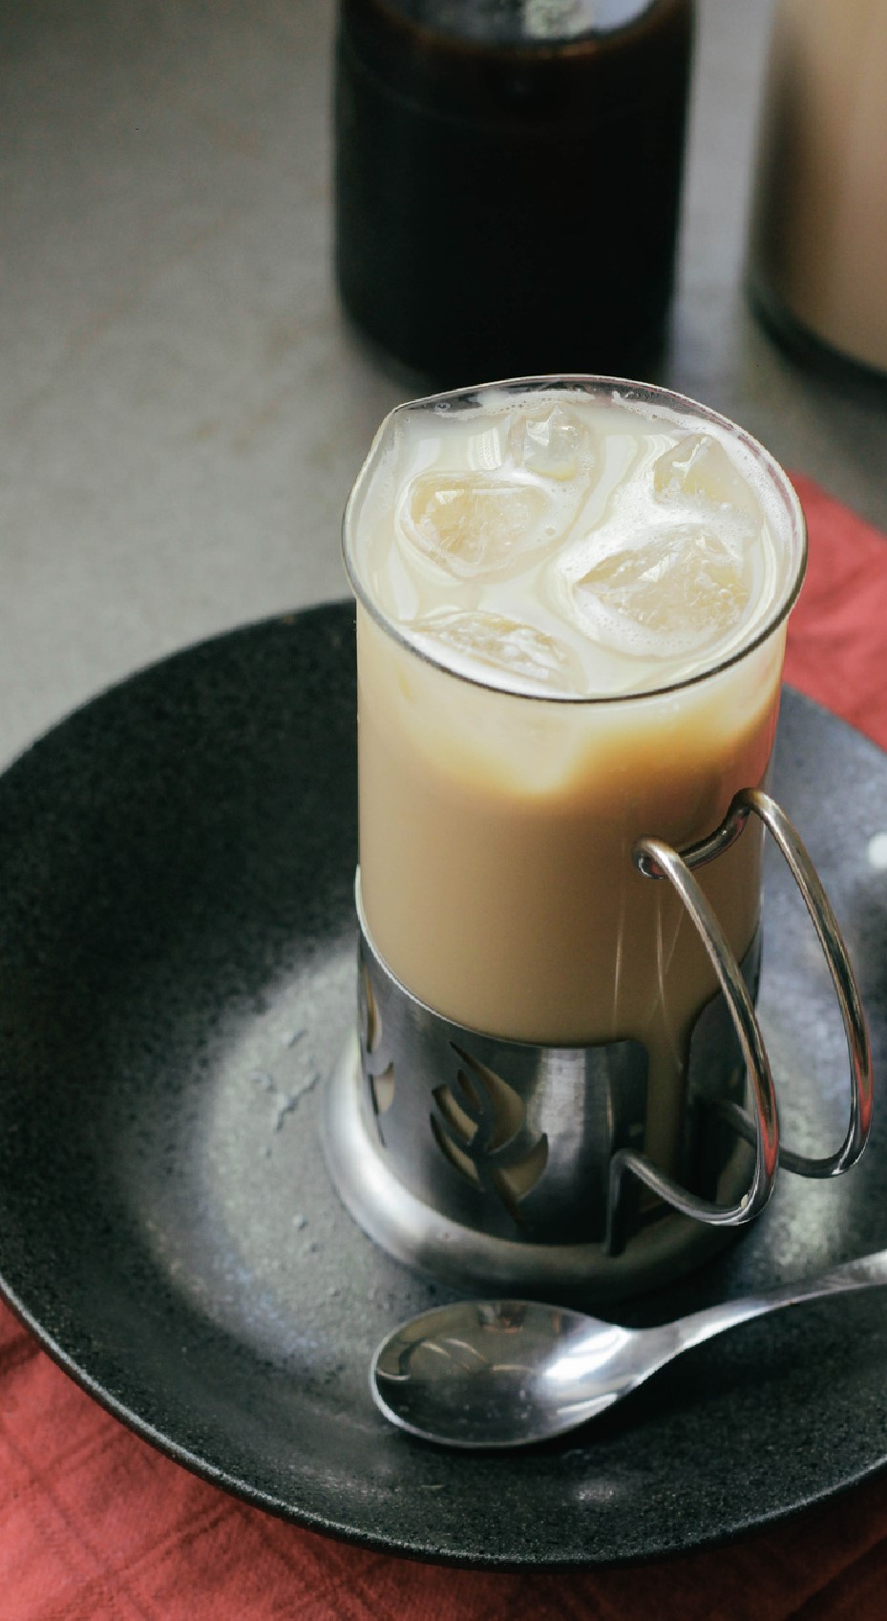

*Support Local*

**BY MOHAMMAD**

**Pumpkin Spice Everything:**

Fall in love with

our Pumpkin Spice Cupcakes, Pumpkin

Cheesecake, and Pumpkin Bread. The warm,

comforting flavors of autumn are here to

stay!

**Caramel Apple Turnovers:**

Enjoy the taste

of freshly picked apples with a rich caramel

twist in our flaky turnovers.

**Maple Pecan Danish:**

It's the perfect blend

of buttery pastry, sweet maple glaze, and

crunchy pecans. You won't be able to resist!

**New Seasonal Treats:**

**New Additions:**

We are now offering Gluten-Free versions of some of your favorite treats. Everyone can now enjoy our delectable goodies! **Customer Spotlight:**

This month, we want to shine a light on our loyal customer, Emily, who has been with us since the

beginning. Thank you, Emily, for your continued

support. We're delighted to have you as part of our Sweet Delights family! **Special Promotions:**

To show our appreciation for your loyalty, we are offering a 15% discount on all items during the first week of November. Use the code

"SWEETNOV" when placing your order.

# copyright Azhara sweets 2023